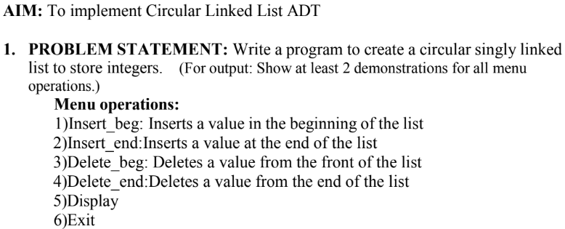

#include <stdio.h>
#include <stdlib.h>
struct node {
int data;
struct node *next;
};
struct node *last = NULL;
void insert_beg(int val) {
struct node *n = (struct node*)malloc(sizeof(struct node));
n->data = val;
if (!last) {
last = n;
last->next = last;
} else {
n->next = last->next;
last->next = n;
}
}
void insert_end(int val) {
struct node *n = (struct node*)malloc(sizeof(struct node));
n->data = val;
if (!last) {
last = n;
last->next = last;
} else {
n->next = last->next;
last->next = n;
last = n;
}
}
void delete_beg() {
if (!last) { printf("List empty\n"); return; }
struct node *temp = last->next;
if (last == last->next) { free(last); last = NULL; }
else {
last->next = temp->next;
free(temp);
}
}
void delete_end() {
if (!last) { printf("List empty\n"); return; }
struct node *temp = last->next;
if (last == last->next) { free(last); last = NULL; return; }
while (temp->next != last) temp = temp->next;
temp->next = last->next;
free(last);
last = temp;
}
void display() {
if (!last) { printf("List empty\n"); return; }
struct node *temp = last->next;
do {
printf("%d ", temp->data);
temp = temp->next;
} while (temp != last->next);
printf("\n");
}
int main() {
int ch, val;
while (1) {
printf("\n1.Insert_beg 2.Insert_end 3.Delete_beg 4.Delete_end 5.Display 6.Exit\nEnter choice: ");
scanf("%d", &ch);
switch (ch) {
case 1: printf("Enter value: "); scanf("%d", &val); insert_beg(val); break;
case 2: printf("Enter value: "); scanf("%d", &val); insert_end(val); break;
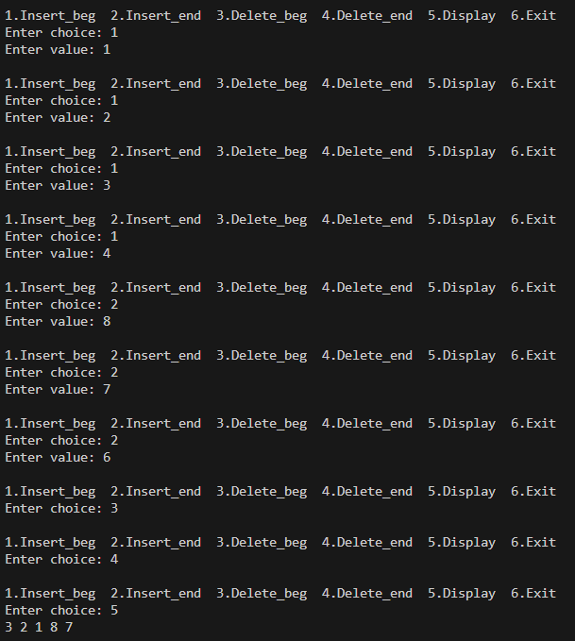
case 3: delete_beg(); break;
case 4: delete_end(); break;
case 5: display(); break;
case 6: exit(0);
default: printf("Invalid choice!\n");
}
}
return 0;
}

